ELECTRICAL DRAWER PLATE

- PARTS:

A. SEE BILL OF MATERIALS.

- ASSEMBLY:

- SEE DIAGRAM 1 FOR LAYOUT.

NOTE 1
USE ACETONE ONLY IN A WELL-VENTILATED AREA WHILE WEARING SAFETY GLOVES.

B. PREPARE AND CLEAN THE SURFACES OF THE PLATE WITH ACETONE AND A CLEAN WIPE.

C. AFFIX 18 ADHESIVE CABLE CLAMPS (46029-) TO THE PLATE USING 3M PLASTIC ADHESIVE, ACCORDING TO DIAGRAM 1.

- MOUNT THE POWER SUPPLIES TO THE PLATE, ACCORDING TO DIAGRAM 1.

- MOUNT THE TRANSFORMER TO THE PLATE, ACCORDING TO DIAGRAM 1.

- MOUNT THE RELAY BLOCKS AND RELAYS TO THE PLATE, ACCORDING TO DIAGRAM 1.

- MOUNT THE TERMINAL MOUNTING RAILS TO THE PLATE ACCORDING TO DIAGRAM 1.

- MOUNT THE TERMINAL BLOCKS, PARTITIONS, AND END PLATES TO THE TERMINAL RAILS.

- MOUNT THE BRIDGE RECTIFIER, RESISTORS, AND CAPACITORS, ACCORDING TO
DIAGRAM 1.

- MOUNT THE SERVO MOTOR AMPLIFIERS TO THE PLATE, ACCORDING TO DIAGRAM 1.

- MOUNT THE MOTION CONTROL BOARD AND I/O BOARD ASSEMBLIES TO THE MOUNTING BRACKETS.

- MOUNT THE BOARD AND BRACKET ASSEMBLY TO THE PLATE, ACCORDING TO
DIAGRAM 1.

- ASSEMBLE THE WIRING HARNESS USING THE LVX-1 WIRING PEGBOARD, AND ACCORDING TO THE GUIDE ATTACHED TO THE PEGBOARD.

N. INSTALL THE PREPARED WIRING HARNESS ONTO THE WIRING PLATE.

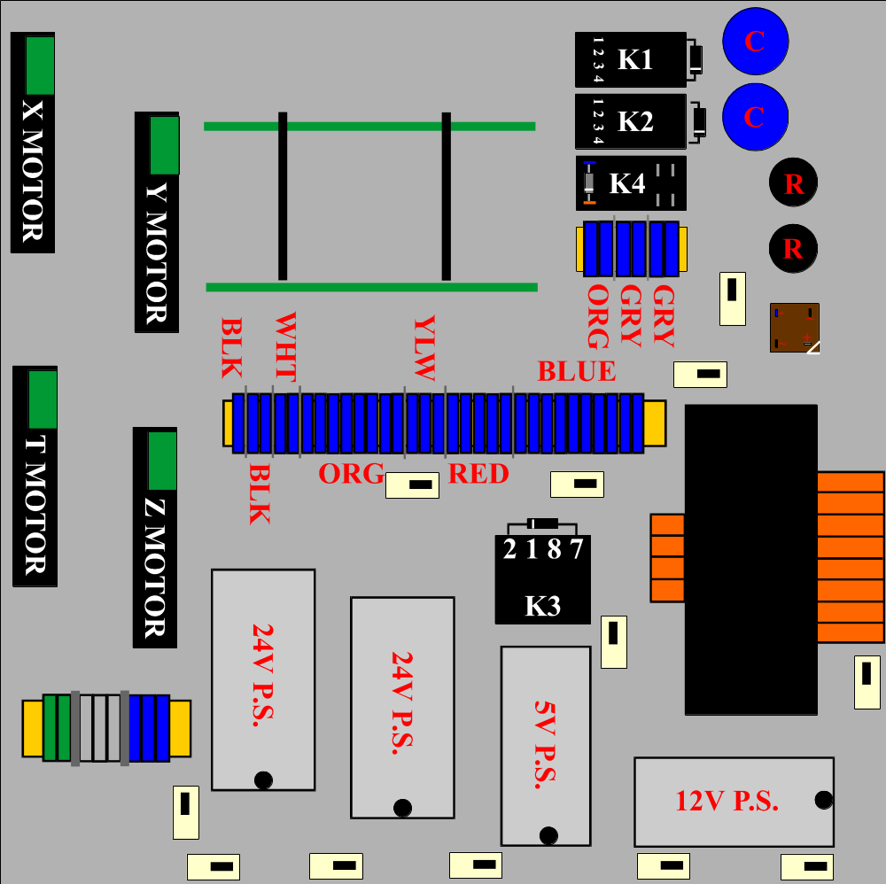

DIAGRAM 1

